T,PRANEETHA
194212588
ECA3102
NANO ELECTRONICS

Exp 2. Simulation of Energy States of Quantum Dot using NanoHub
Case Study 2: Simulate the energy states of two layer cuboid quantum dots
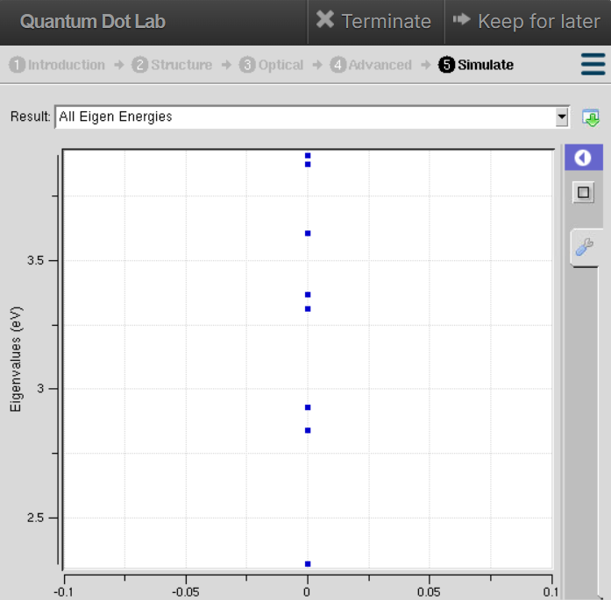

Here, the geometry is cuboidal with layered confinement, which restricts electron motion more strongly in at least one dimension. The graph shows that the energy levels are more widely spaced compared to the cylindrical case. This stronger confinement increases the band gap, pushing emission toward shorter wavelengths (blue/green region). The sharper separation of energy states in the graph illustrates how geometry and dimensional asymmetry can be engineered to tune optical properties. This case study emphasizes that shape, not just size, plays a critical role in determining quantum dot behavior.

Case Study 1: Simulate the energy states of cylindrical quantum dots of X=15 nm, Y=10.5nmand Z = 8 nm.
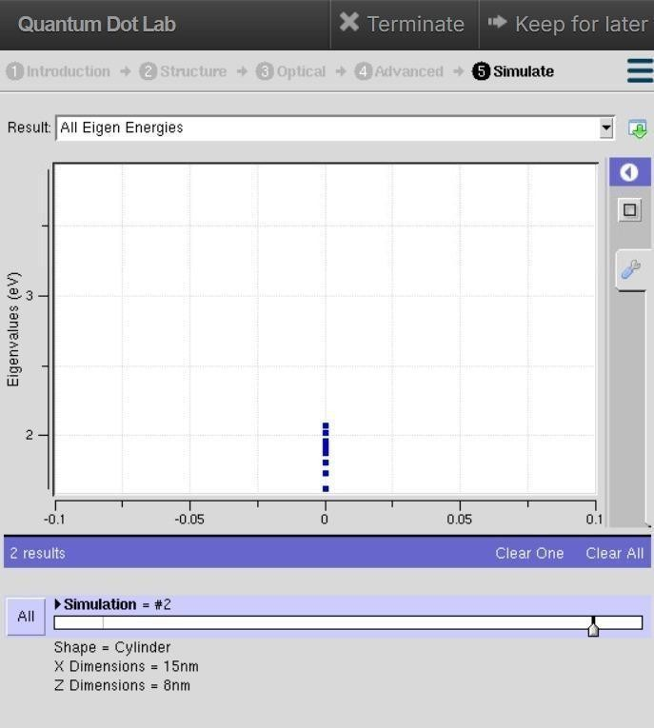
In this case, the quantum dot is modeled with cylindrical geometry (X = 15 nm, Y = 10.5 nm, Z = 8 nm). The larger dimensions reduce the confinement effect, so the energy levels appear closer together in the graph. This means electrons require less energy to transition between states, resulting in smaller band gaps. Consequently, the emission shifts toward longer wavelengths (red/orange region). The graph highlights how increasing the dot size lowers the energy separation, demonstrating the principle that confinement strength is inversely related to quantum dot dimensions.

Conclusion
The simulation shows that the cuboidal geometry provides stronger electron confinement, resulting in widely spaced energy levels and a larger band gap. This confirms that the shape of a quantum dot significantly influences its electronic and optical properties.

